**PHOTOGRAPHY CONTEST**

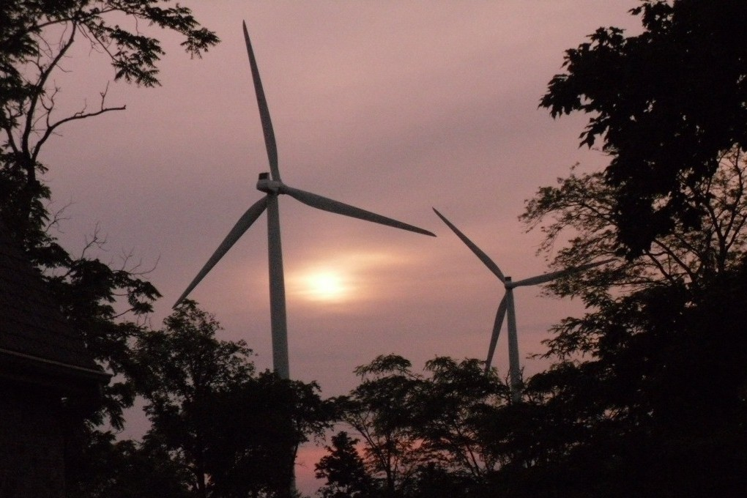

The top twelve photos will be featured in next year’s calendar! Submit entry to Granger Camera House in Channahon by August 31. Photos will be judged on composition, originality, and impact. Judge’s decisions are final.

**RULES**

* Amateur and youth photographers only
* Unframed 8”×10” color or black-and-white photo in **landscape** orientation
* Digital alterations *not* allowed

**Questions? Call 555-4454.**